VIBRATORY POWER DISTRIBUTION PCB

- PARTS:

QUANTITY: PART #: NOMENCLATURE:

1 PER BOARD (4 PER MACHINE) 217005- PCB, VIBRATORY POWER DISTRIBUTION

6 PER BOARD (24 PER MACHINE) 17627- CONNECTOR, PCB HEADER, 3-POSITION

- ASSEMBLY:

- PLACE THE SEVEN HEADERS IN THE APPROPRIATE LOCATIONS AND SOLDER THEM, ACCORDING TO DIAGRAM 1.

NOTE 1
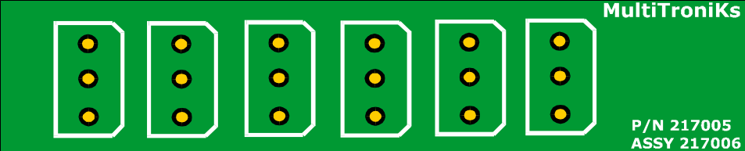THE HEADERS HAVE A D-SHAPE TO THEM. MAKE SURE THAT THE THEY ARE ORIENTED ACCORDING TO DIAGRAM 1.

DIAGRAM 1

